Communication with DashMessaging website (mobile)

Server
The mobile application that should be communicating with the server.
Server IP might change over time, for latest “host” address (in case when something is wrong or you see that provided IP is not operational) please contact to Ganesh, Rahul or me.

Host’s URL address to be used (let’s call it “{{host}}” parameter):

(latest) https://dashmessaging-com.ngrok.io
(obsolete) https://35f2-3-17-141-5.ngrok-free.app

Server accepts POST requests, and you can send messages to the following endpoint:
Endpoint URL: “{{host}}/scheduler/mobile-app”

The object that endpoint accepts on the server side:

public class IncomingMobileMessage implements Serializable {
private String userId;
private String messageId;
private String messageText;
private Long messageTime;
private Integer eventTypeCode;
private String fcmToken;

…

Getters and Setters, rest of the boilerplate code…
]

That means the expected JSON object should have content like this:

{
"userId": "pUuutN05eoVeWhsKyXBiwRoFW9u1",
"messageText": "#deactivate",
"messageTime": 1710072000,
"messageId": "70ae2ec3-55f7-4aa2-9c35-eb963b8fbd2b",
"eventTypeCode": 1, (1 if that is a regular text, 2 if it was Quick Reply button click)
"fcmToken": “PARTICIPANT_RELATED_TOKEN”,
}

When server sends data to the mobile application, the object that is received has following structure on the mobile side (currently Kotlin-based version has following structure)

@Serializable
data class QuitxtServerIncomingDto(
val recipientId: String,
val serverMessageId: String,
val messageBody: String,
val timestamp: Long,
val isPoll: Boolean,
val pollId: Long?,
val fcmToken: String?,
val questionsAnswers: LinkedHashMap<String, String>?
)

Linked Hash Map is necessary for keeping the buttons’ order, it can be empty if a regular message was received from the server side, but if that was a poll, then key and value of entry will contain same value, so you can take either all keys or all values in the same order that server provided.

“fcmToken” parameter:
This parameter is responsible for future callback handling from the server side.
It is associated with each participant and will help Firebase to understand where (to which device) to send the message from DashMessaging website.

This is a parameter (value) that Firebase generates for each user (can’t say at this moment whether this token is device-unique or not)

For example, the value might look like this:

e-D8y5f8RoOcRgQl4AV18K:APA91bEdH6CwssC17yIKENOuLiW5eOxnE5CaOxqiOkKXdL4ZgnbOAk9s1_EX0w0E4G0c_zn5QD8X7W0-BHGooS2RyBcfHFYl8hfNEwYVcNIEConIJTyeJnhAnxlhD3OwayB6S_yeZXST

So, please be aware that this String is a bit long and if you are storing it in database, make sure that corresponding column length is sufficient.

Firebase

QuiTXT Mobile – this is the URL for the Firebase Console:
https://console.firebase.google.com/u/0/project/quitxtmobile/overview

Please let me know whether you have access to it or there are also permissions that should be granted.

Mobile Application
For the mobile application you should be able to see the Play Market app on the website.
Aside of that there is a link for testing (internal testing via invitation):
https://play.google.com/apps/internaltest/4701702178001406143

Please let me know whether this link is available for you as well

Application flow
General flow for the Android application is following:
Login page:

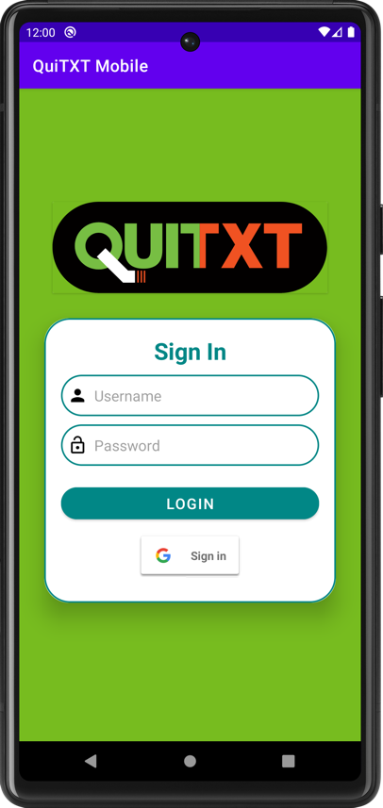

Here 2 options should be available – login via username+password or Gmail signin option. Assuming I successfully logged into the application. There will be the main screen with “Navigation” block on the left and “Fragment” depending on the chosen option on the right:

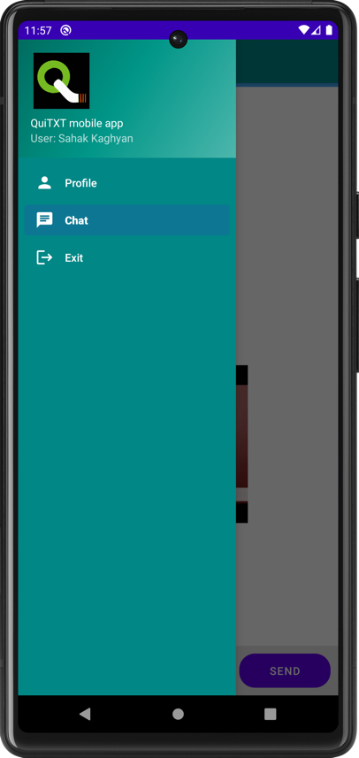  Navigation pane | 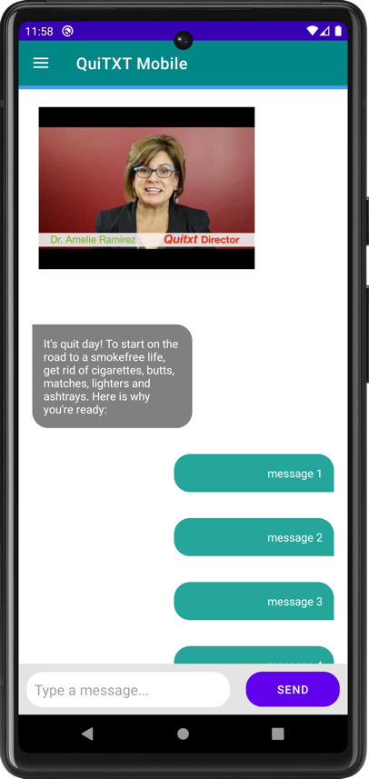  Chat fragment | 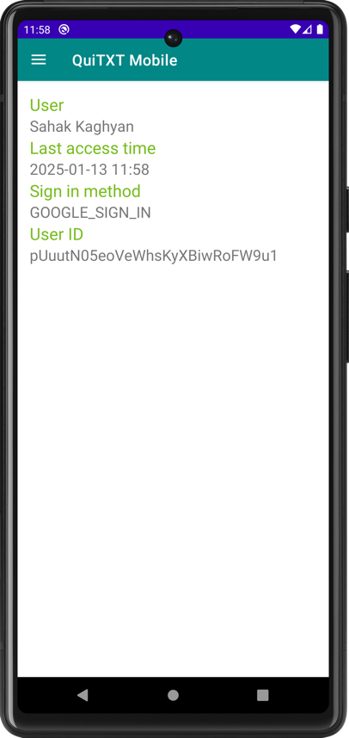  Profile menu

For the chat application:

- There can be just regular text coming from server side.
- There can come text where part of it is a regular string, the rest is a YouTube URL link.
Example:
Welcome to Quitxt from the UT Health Science Center! Congrats on your decision to quit smoking! See why we think you're awesome, Tap pic below https://youtu.be/ZWsR3G0mdJo
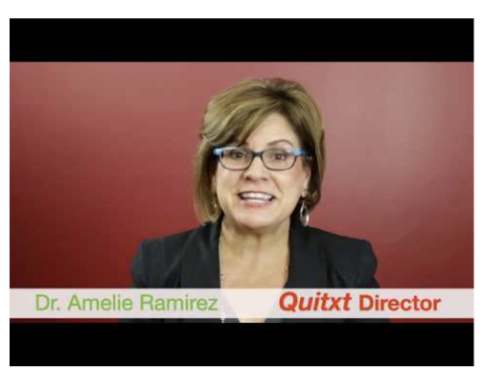
Message should be rendered in 2 parts: regular text should be displayed; YouTube URL link should be used to render the image from YouTube
- There can come text where part of it is a regular string, the rest is a QuiTXT website URL link. Again, regular text will be displayed and instead of link, a metadata text should be displayed from website URL analysis.
Example:
We'll help you quit smoking with fun messages. By continuing, you agree with our terms of service. If you want to leave the program type EXIT. For more info Tap pic below https://quitxt.org
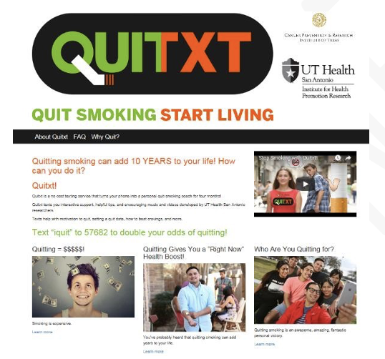
- Instead of regular message a poll can come. The inner structure (as mentioned) will contain LinkedHashMap with poll answers (up to 8 answers are allowed to be displayed).
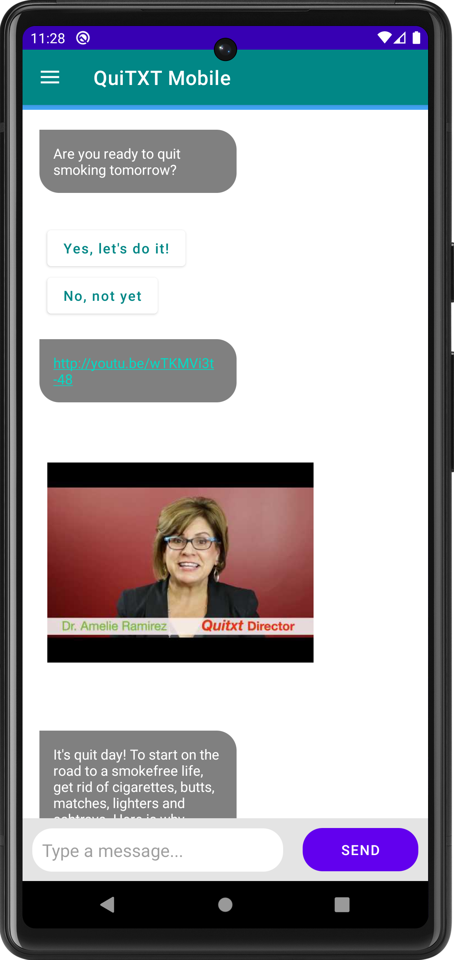
- A gif can come along with regular text.
Example:
Reason #1 to quit smoking while you're young: You'll have more time to enjoy hoverboards and flying cars. https://quitxt.org/sites/quitxt/files/gifs/PreQ6_Hoverboard.gif


The application should support Spanish language as well. I am currently adding a switch on the mobile application to tell Server in which language user wants to communicate. Example of texts during a certain day:

Pre-Quitting Day -5
(Timed as requested – DEFAULT 8:00 AM):

PQ-5BD – 8am:
Drinking alcohol can trigger cravings for a cigarette and makes it harder for you to quit smoking. Tap pic below https://quitxt.org/binge-drinking

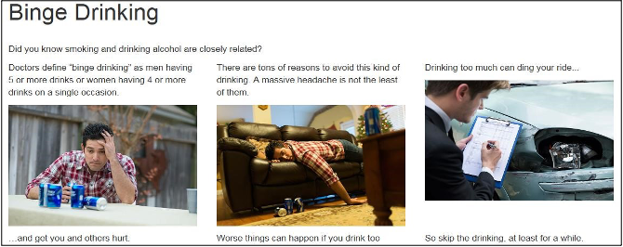

Beber alcohol puede provocar los deseos de fumar y te hace más difícil dejar el cigarrillo. Clic el pic abajo https://quitxt.org/spanish/consumo-intensivo-de-alcohol

PQ-5Cue1 Messaging – Noon:
Like the Avengers protect the earth, you are protecting your lungs from respiratory diseases and cancer! Stay SUPER and quit smoking!
https://quitxt.org/sites/quitxt/files/gifs/App1_Cue1_Avengers.gif

Como los Avengers protegen el planeta, ¡tú estás protegiendo tus pulmones de enfermedades respiratorias y de cáncer! ¡Sigue SUPER y deja de fumar!

PQ-5Motiv2 Messaging – 4pm:
Reason #2 to quit smoking while you’re young: Add a decade to your life and see the rise of fully automated smart homes; who needs to do chores when robots become a common commodity! https://quitxt.org/sites/quitxt/files/gifs/App1-Motiv2_automated_home.gif

Razón #2 para dejar de fumar siendo joven: ¡ganarás 10 años de vida y verás el aumento de las casas inteligentes; ¡quién necesita limpiar la casa cuando los robots lo harán por ti!
https://quitxt.org/sites/quitxt/files/gifs/preq5_motiv2_automated_esp.gif

